**Node must be install on the system.**

Create folder “test” at C:\Users\faisal.habib.ansari\Desktop\test

where we put JavaScript file containing test cases.

In “test” folder create package.json file containing dependencies as below

package.json

{

"name": "facade-proxy-test",

"version": "0.0.1",

"devDependencies": {

"chai": "*",

"mocha": "*",

"supertest": "*"

},

"scripts": {

"test": "mocha test.js"

}

}

Now go to “test” folder through command prompt and run command

“npm install”

To install all dependencies.

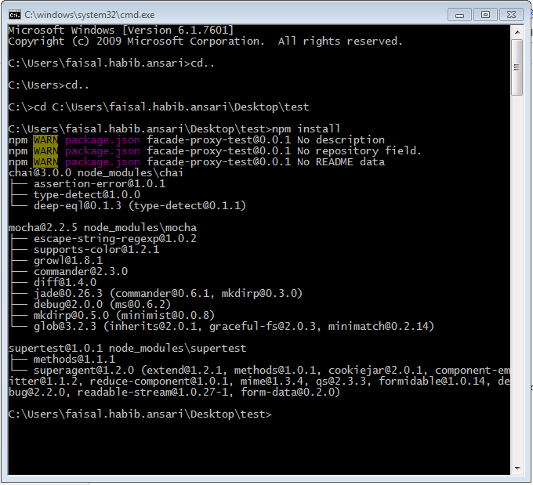

Now run command

mocha --timeout 20000 --reporter nyan <<testScriptFileName>>.js

to run test cases